Power Shell 101
Module 5 Hands-on Activity – PowerShell in VSCode
5/8/2019 Developed by Jin Chang, Sion Yoon
5/11/2019 Tested by Sion Yoon, Jin Chang
Center for Information Assurance (CIAE) at City University of Seattle

Learning Outcomes
- Review on using the pipeline
- Learn about different operators including the dollar sign-underscore-dot operator
- Learn how to use variables to store objects
- Learn about for and foreach

Resources
- Operators
- https://www.varonis.com/blog/windows-powershell-tutorials/
- Using variable to store objects
- https://docs.microsoft.com/en-us/powershell/scripting/learn/using-variables-to-store-objects?view=powershell-6
- Dollar sign-underscore-dot operator
  - http://techgenix.com/dollar-sign-underscore-dot/
- For, foreach and foreach-object
  - https://docs.microsoft.com/en-us/powershell/module/microsoft.powershell.core/about/about_for?view=powershell-6
  - https://docs.microsoft.com/en-us/powershell/module/microsoft.powershell.core/about/about_foreach?view=powershell-6
  - https://docs.microsoft.com/en-us/powershell/module/microsoft.powershell.core/foreach-object?view=powershell-6
  - http://techgenix.com/powershell-foreach-loop/

Activities
- Pipeline Review
- Operators
- Using Variable to Store Objects
- Dollar Sign-Underscore-Dot Operator
- For and Foreach
- Q&A

Pipeline Review

- Open PowerShell in VSCode.

- We all learned about the pipeline, but let’s quickly review the operator. The output from one command is used as an input for the next command in the pipeline, % A | B | C | D and so on. Therefore, the output of A now becomes an input to B, and the output of B becomes an input to C and so on.

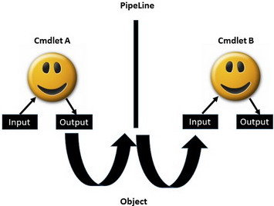
http://badbitboy.blogspot.com/

- Before expanding more on this, type:

% Get-Service –Name audiosrv

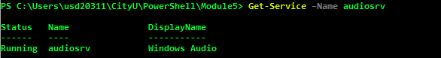

The output from the cmdlet A is essentially an object (service object = audiosrv) that carries properties, methods, and events, etc. From the audiosrv object, we can see they have three properties listed from the command line, Status, Name, DisplayName. For instance, you can imagine a house and its property includes “Address”, “Year-Built”, and “Color” etc.

- Now using the questions in our Module 4 hands-on-activity as an example, type:

% Start-Process PowerShell –Verb RunAs

% Get-Service –Name audiosrv | Stop-Service

% Get-Service –Name audiosrv | Start-Service

We have the audiosrv object being passed over to the next cmdlet (Stop-Service or Start-Service), and it’ll use the service object as an input to finish its operation. Note that you can simply use the following two cmdlets as it is easier with less typing. This is to give you practice using the pipeline.

% stop-service audiosrv

% start-service audiosrv

Operators

- Below is a list of operators that are commonly used:

Operator Name | Operators | Description
Comment block Operator | # | Words after # will be ignored.  Get-Process # getting all the Windows processes
Arithmetic Operators | +, -, *, /, % | These can be used with the following data types, Int, String, DateTime, HashTable.  “Hello ” + “World”  (Get-Date).AddDays(-1)  7%2
Assignment Operators | =, +=, -=, *=, /=, %=, ++, -- | These are used to assign, change or append values to variables.  $a = “Hello ”  $a += “World”
Comparison  Operators | -eq, -ne, -gt,  -lt, -le, -ge | They are used to compare values or perform a test.  “hello” –eq “Hello”  1,2,3 –ne 2  1,2,3 –gt 1
Split/Merge Operators | -split  -join | These are useful to manipulate strings, dividing, combining substrings.  -split “red yellow blue green” “Lastname:Firstname:SSN” –split “:”  -join “a”, “b”, “c”  -join(“a”, “b”, “c”)  “CityU”, “Seattle” –join “@”
Call Operator | & | This executes commands that are stored in variables and represented by strings or script. Note that this doesn’t parse additional parameters.  $c = “Get-ExecutionPolicy”  @ $c
Comma Operator | , | The comma creates an array.  $myArray = 1,2,3
Cast Operators | [ ] | This converts to objects to the specified type.  [datetime]$birthday = “1/28/1993”  [int64]$a = 34  Also, provides access to an array.  See below.
Hash Table Operator | @{key=”value; ; } | A paired list of key and value. For example,  $h = @{key="value"; name="PowerShell"; version="2.0"}  To access the value  $h[“name”]  $h[“version”]
XML Operators | [xml] | XML parsing operator. For example,  $x = [xml]“<doc><intro>Once upon a time …</intro></doc>”  $x[“doc”]
Range Operator | .. | Generates the sequential integers or characters defined in the range.  $list=1..10  $max=10  Foreach ($list in 1..$max) { Write-Host $list}
Array Subexpression Operator | @( ) | It returns the result of one or more statements as an array.  $ray = @(1,2,3,4)
Subexpression Operator | $( ) | Command from $(cmd) is executed when it is combined with “ ”  $ray = @(1,2,3,4)  Write-Host “$ray.length”  Write-Host “$($ray.length)”

- Let’s practice using these operators. The first cmdlet below will simply get you the date but what if you want the day of the year, the day of the week, the hour, or today’s day? You can use the parenthesis and dot operator to narrow your search. Type,

% get-date

% (get-date).dayofyear

% (get-date).dayofweek

% (get-date).hour

% (get-date).day

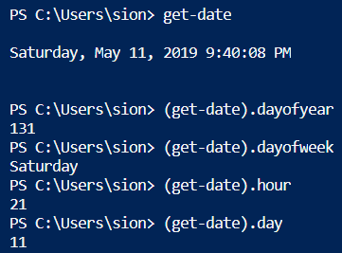

- If your supervisor tells you that you have 10 days to complete a project and you want to know the date after 10 days, type:

% (get-date).adddays(10)

Using Variable to Store Objects

- You can get the same results by creating a variable. Choose what you want to name the variable. I’m going name my variable “date”. PowerShell only creates the variable if it does not exist. Type your variable along with a dollar sign in the front of the variable to see if it returns a result.

% $date

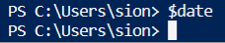

It returns no result because it does not have a value. It means that you can create a variable and assign it a value.

- The following command will send the output of get-date to $date. Do the same for the name of the variable that you have created.

% $date = get-date

- Now type your variable along with a dollar sign in the front of the variable to see if it returns a result. You should now get the date information.

- Type “Month:” in quotes to display the text and use “.month” after the variable that you have created to get the month.

% “Month: “ + $date.month

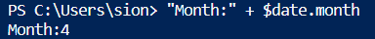

Do the same for the day of the year, the day of the week, the hour, or today’s day. Screenshot and paste your results here:

Q&A #1
Your screen capture

Dollar Sign-Underscore-Dot Operator

- Now, let’s take a special operator, $_. This is used in conjunction with pipe. Often times, you will come across the sign “dollar-underscore-dot” from the various pipe related examples in the books and online resources. What is it? When can I use it? First, it is a type of variable. From the part above, we know that $ followed by a name makes a variable. That same “$” can be concatenated by “_.” And used by a variable in the pipeline. When the output of the previous command is stored into “$_.” and the next command will access the objects via “$_.” for the current operation.

Where-Object {$_.} is the way the object from the previous cmdlet carries over to the next cmdlet. Type:

% Get-Service –Name audiosrv | Where-Object {$_.Status –eq “Running”}

This will display an audiosrv service object if its status is “equal” to “Running”

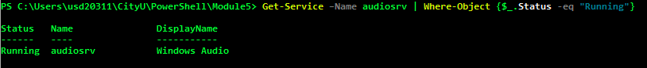

But if you try the following command, nothing will return.

% Get-Service –Name audiosrv | Where-Object {$_.Status –eq “Stop”}

- Finally, let’s then open ALL the services that have their status in “Running”

% Get-Service | Where-Object {$_.Status –eq “Running”}

For and Foreach

- for loop is used for continuous running of statements based on a conditional test. Here is the syntax.

for (<initialization>; <condition>; <repeat>)
{
< statement execution >
}

- Here is an example. You can try this example in the command line. Make sure the drop down box on the top right of the terminal is set to “powershell”, not the PowerShell Integrated Console”.

for($i = 1; $i –le 10; $i++)
{
Write-Host $i
}

- foreach traverse all the items in a collection of items. The syntax is following.

foreach ($<item> in $<collection>)
{
< statement execution >
}

- Here is an example. You can try this example in the command line.

$Array = “a”,“b”,“c”,“d”

foreach($letter in $Array)
{
Write-Host $letter
}

Q&A #2

Using for loop, write a cmdlet that displays the multiples of 10 from 0 to 100. Insert your screen capture here. (hint: use += )

***Start from 0

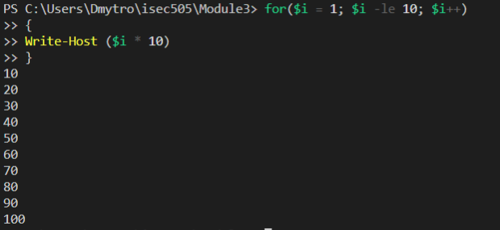

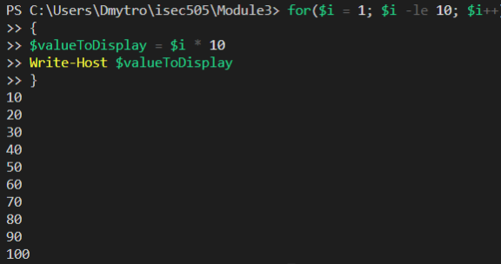

- Let’s check out another loop cmdlet. This time, it is called foreach-object. This is a pipeline variation of the foreach loop. foreach-object operates on each item in a collection of input objects rather than a single object (cf. where-object)

<cmdlet> or <object> | foreach-object

To use this cmdlet, you would pass a collection of objects via cmdlet or array of strings or number or objects, and then pipe to foreach-object.

Here is an example.

"CityU.At.Seattle" | foreach-object {$_.Split(".")}

